Practical 1
Q: CREATE A DOCUMENT CONTAINING TEXT THAT SHOULD BE PROPERLY ALIGNED WITH PROPER FORMAT. USE THE REPLACE ALL OPTION IN FIND & REPLACE TO REPLACE EACH INSTANCE OF SOME WORD. SAVE & PROTECT YOUR DOCUMENT.

REPLACE ALL OPTION
- Enter the Text and use Justify button in paragraph.
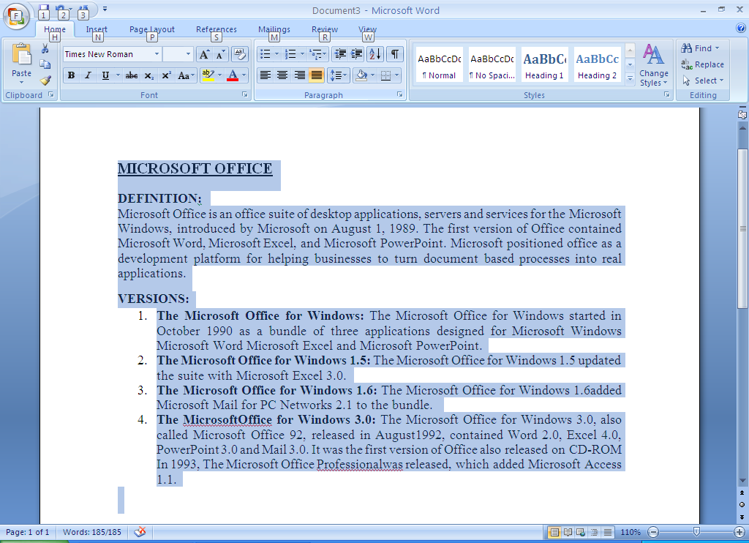
- Use Replace button in Editing Group and replace Microsoft with (MS).
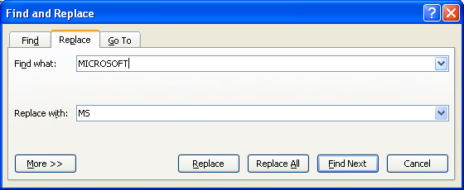

- Texts after replacement are highlighted.
`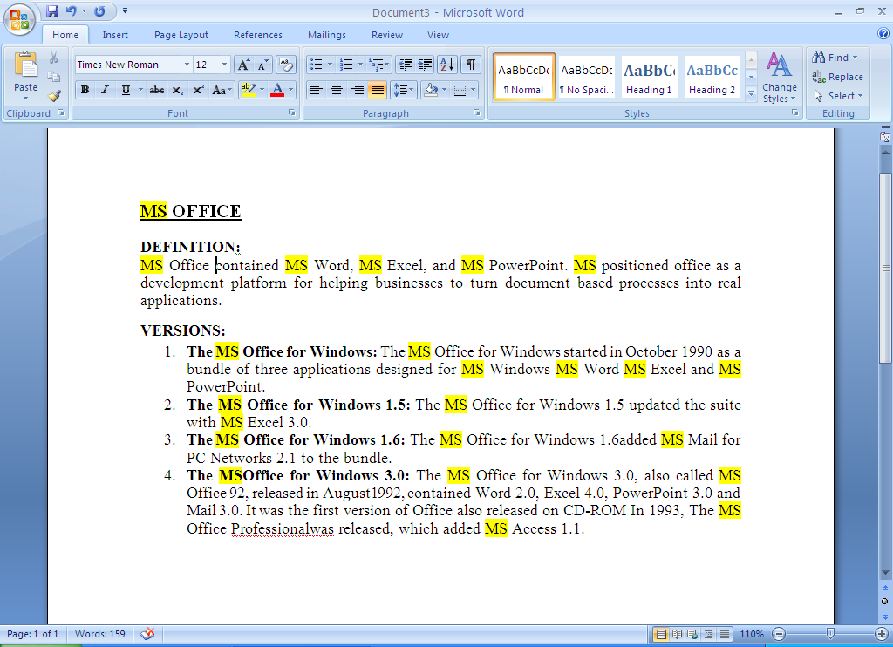

SAVING A DOCUMENT
- Click on Office button.
- Then click on Save.
- Set the desired Location and File name.
- Press ok.

PROTECTING YOUR DOCUMENT
- Click on Tools options in Save window.
- In tools click on general options.
- Create password for open document
- Also enter password for modify the document and click ok

